**BOBIT/LMR/1433/18**

**FREBE TEXTILE COMPANY**

This project is dealing with a textile company that sells fabric. The company deals mainly with tailor’s corner for tailors, uniforms for schools and corporates and African wear for events.

**HOMEPAGE**

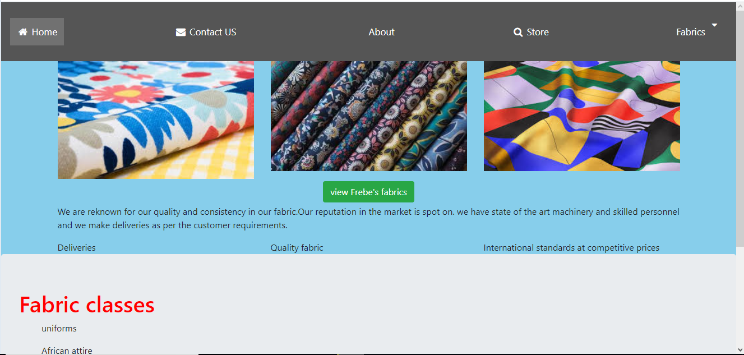

**CONTACT US PAGE**

Customers can get back to us in case of any issues.

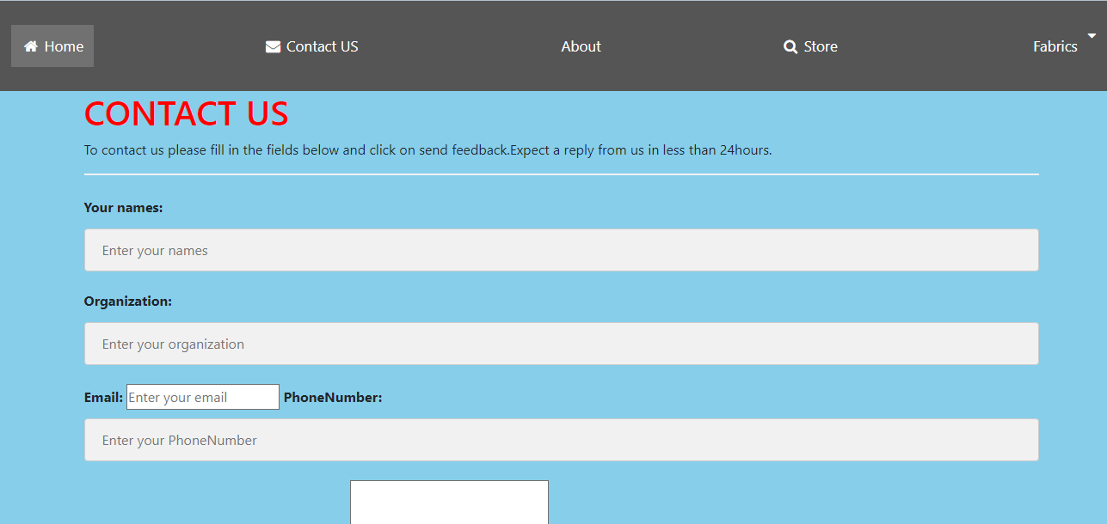

The page also has a captcha which is required before a customer can send us anything for security and also avoiding bots.

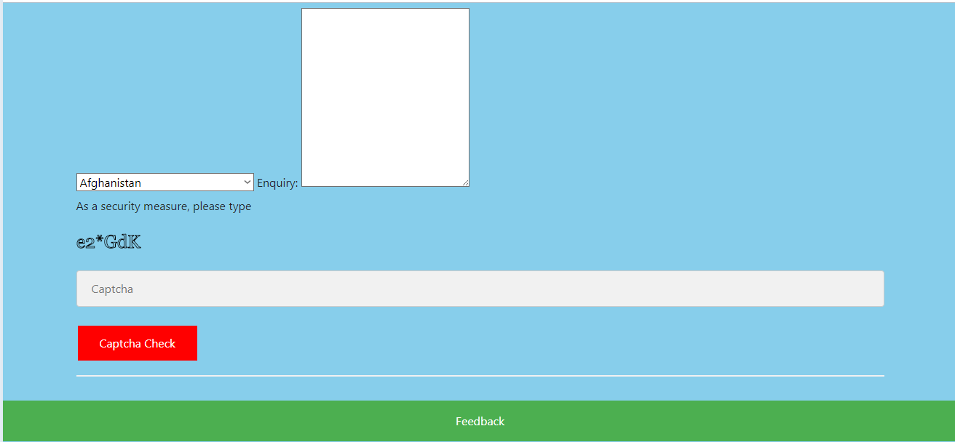

**ABOUT PAGE**

This gives information on Frebe textile company.

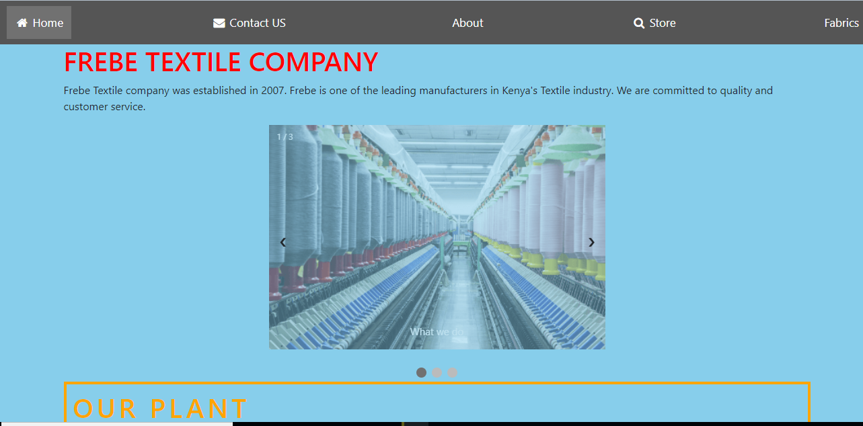

**THE STORE**

This shows all the fabric and an option to put them in the cart.

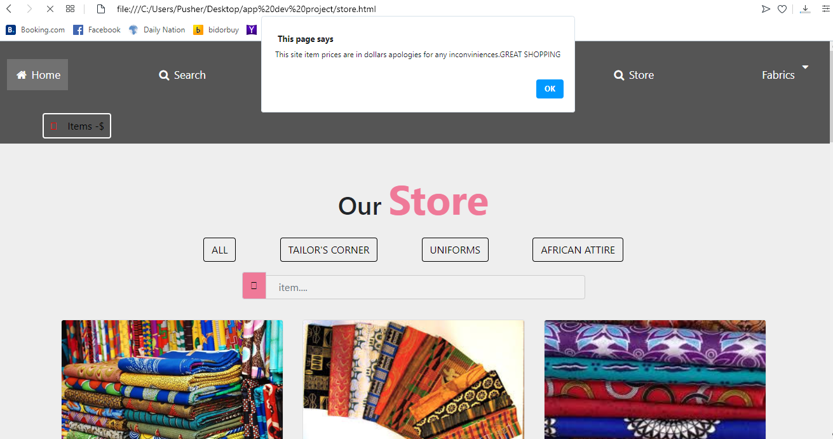

**WHEN THE CUSTOMER CLICKS ON THE CART**

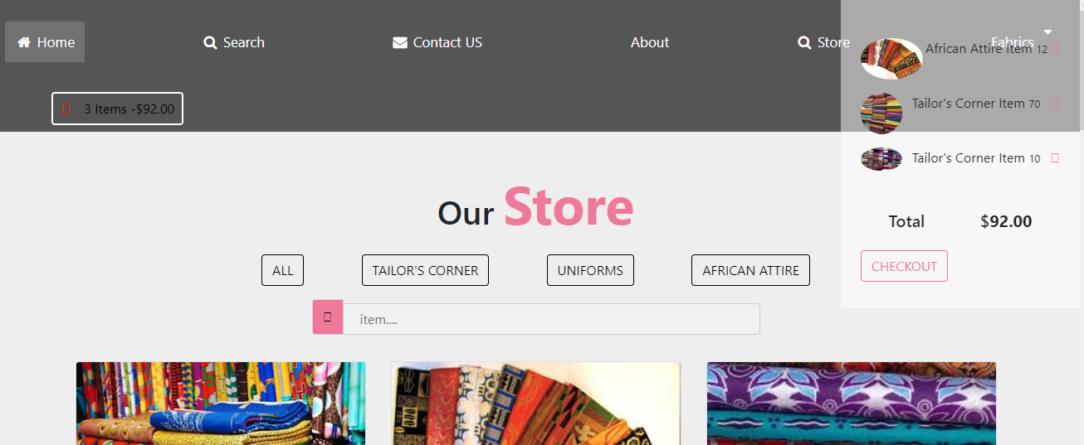

**WHEN THEY CHECK OUT THE PAGE REFRESHES**

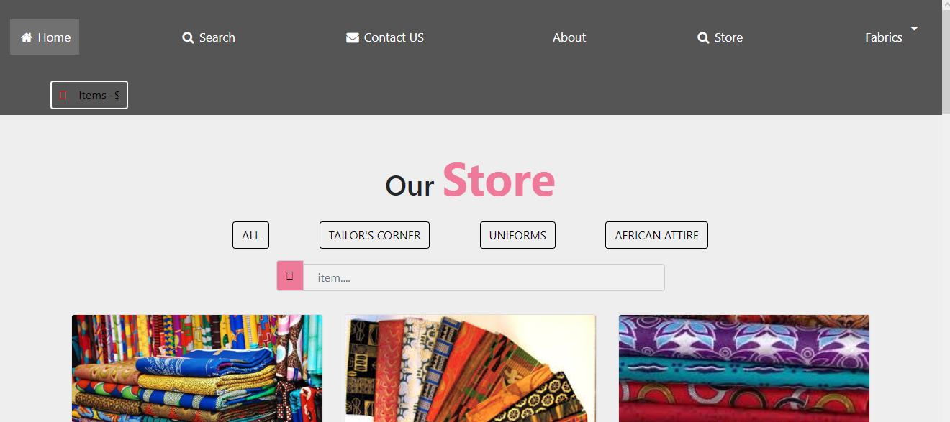

**FABRICS PAGE**

**This page is for the window shoppers who are looking to view the products and also have them categorized into uniforms,tailors corner and affrican attire.**

**It has adrop down menu to the various pages.**

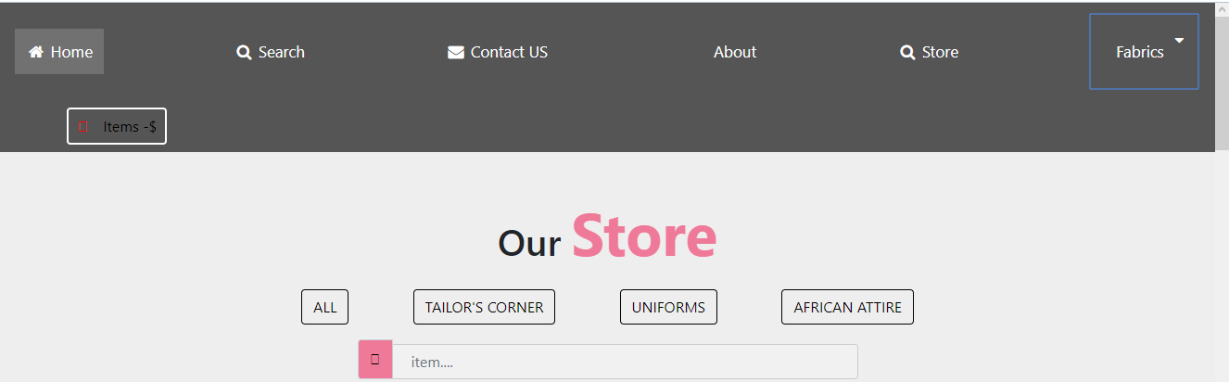

**WHEN THEY CLICK ON AFRICAN ATTIRE**

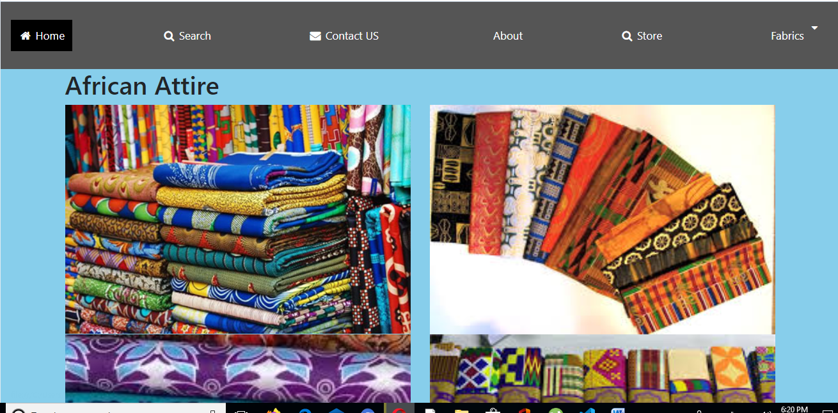

**ON UNIFORMS**

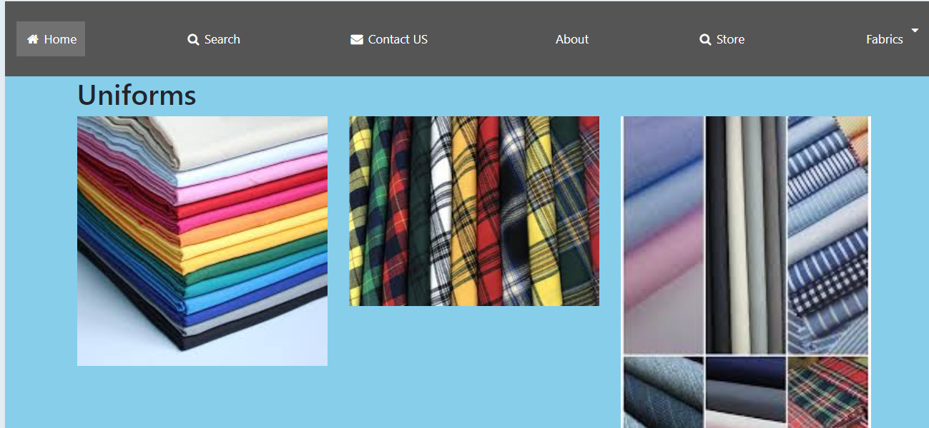

**ON TAILOR’S**

